TRIGGER:

CREATE OR REPLACE TRIGGER log_dept

AFTER INSERT OR UPDATE OR DELETE ON employees

BEGIN

INSERT INTO log_table (userid,logondate)

VALUES (USER, SYSDATE);

END;

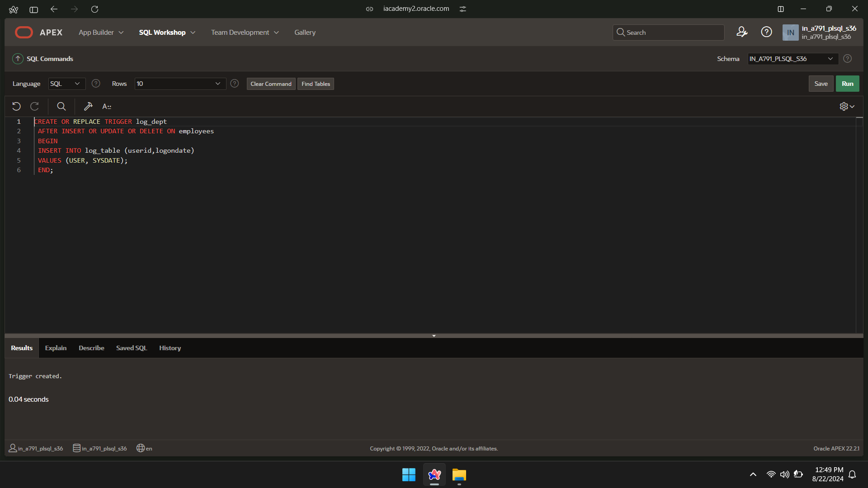

UPDATE employees

SET SALARY=30000

WHERE empid=100;

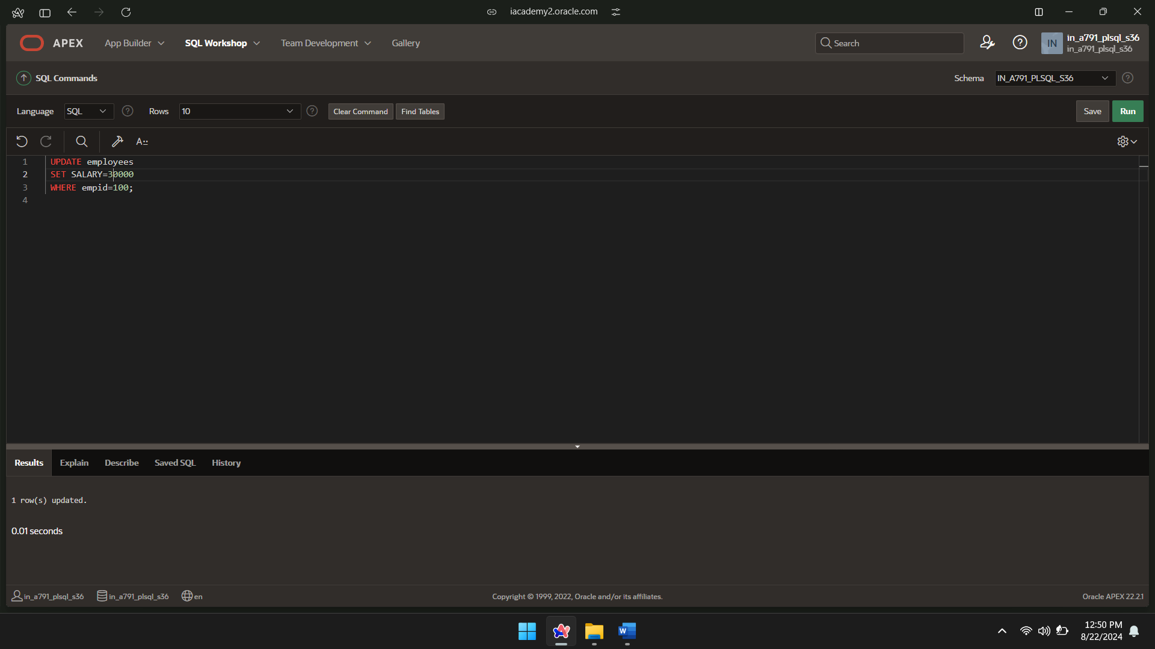

SELECT *FROM log_table;

